PROJECT REPORT

INTRODUCTION

1.1Overview

**c**[**onstruction is the process of building or forming the structure of a building or any other component**](https://www.bing.com/ck/a?!&&p=43a8b4fc7965c700JmltdHM9MTY5NzMyODAwMCZpZ3VpZD0zYzE1N2M1Zi0yZjYzLTY3ZDYtMjdiYS02ZmRjMmU1MDY2NDYmaW5zaWQ9NTgyOA&ptn=3&hsh=3&fclid=3c157c5f-2f63-67d6-27ba-6fdc2e506646&psq=description+about+the+contruction&u=a1aHR0cHM6Ly9idWlsZGluZ2NsYXJrLmNvbS93aGF0LWlzLWNvbnN0cnVjdGlvbi1pbmR1c3RyeS8&ntb=1)**.**[**It is also the art, trade, or work of building**](https://www.bing.com/ck/a?!&&p=656e9dee891ed399JmltdHM9MTY5NzMyODAwMCZpZ3VpZD0zYzE1N2M1Zi0yZjYzLTY3ZDYtMjdiYS02ZmRjMmU1MDY2NDYmaW5zaWQ9NTgzMg&ptn=3&hsh=3&fclid=3c157c5f-2f63-67d6-27ba-6fdc2e506646&psq=description+about+the+contruction&u=a1aHR0cHM6Ly93d3cudGhlZnJlZWRpY3Rpb25hcnkuY29tL2NvbnN0cnVjdGlvbg&ntb=1)**.**[**Construction involves various materials, tools, methods, and designs. Construction can refer to something that is constructed, such as a building, framework, or model**](https://www.bing.com/ck/a?!&&p=2b704f5406513dc8JmltdHM9MTY5NzMyODAwMCZpZ3VpZD0zYzE1N2M1Zi0yZjYzLTY3ZDYtMjdiYS02ZmRjMmU1MDY2NDYmaW5zaWQ9NTgzNQ&ptn=3&hsh=3&fclid=3c157c5f-2f63-67d6-27ba-6fdc2e506646&psq=description+about+the+contruction&u=a1aHR0cHM6Ly93d3cudGhlZnJlZWRpY3Rpb25hcnkuY29tL2NvbnN0cnVjdGlvbg&ntb=1)**.**[**Construction is also an occupation or industry that involves building**](https://www.bing.com/ck/a?!&&p=6b13308406d26a68JmltdHM9MTY5NzMyODAwMCZpZ3VpZD0zYzE1N2M1Zi0yZjYzLTY3ZDYtMjdiYS02ZmRjMmU1MDY2NDYmaW5zaWQ9NTgzOA&ptn=3&hsh=3&fclid=3c157c5f-2f63-67d6-27ba-6fdc2e506646&psq=description+about+the+contruction&u=a1aHR0cHM6Ly93d3cuZGljdGlvbmFyeS5jb20vYnJvd3NlL2NvbnN0cnVjdGlvbg&ntb=1)**.**

1.2 Purpose

In simple term, a project is a sequence of the related tasks and activities that help me create something new or change an existing product, service, or organization.

1. Foster clear and effective communication
2. Set clear goals for my project
3. Work with a flexible team whose skills combine

2 PROBLEM DEFINITION &DESIGN THINKING

2.1 Empathy map

https://github.com/aarthisudha/Construction_nm2023TMIDB24504.git

3 RESULTS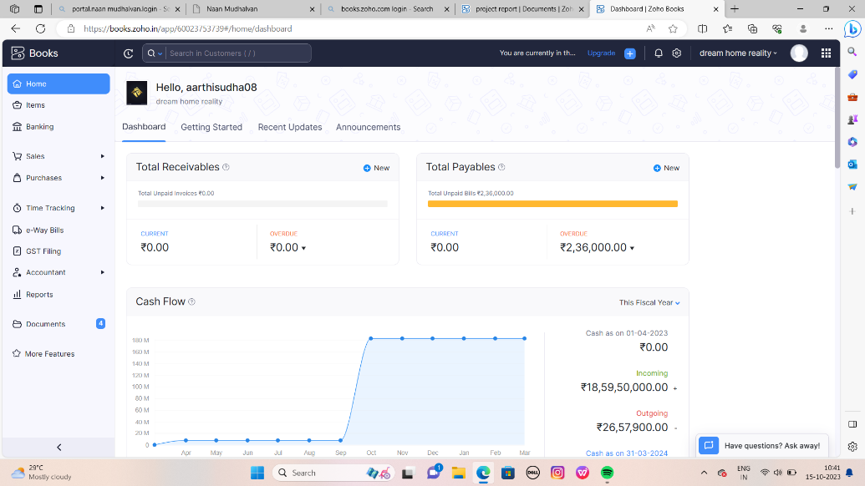

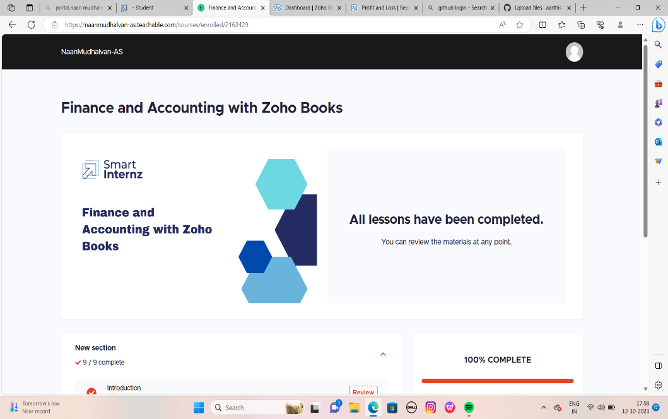

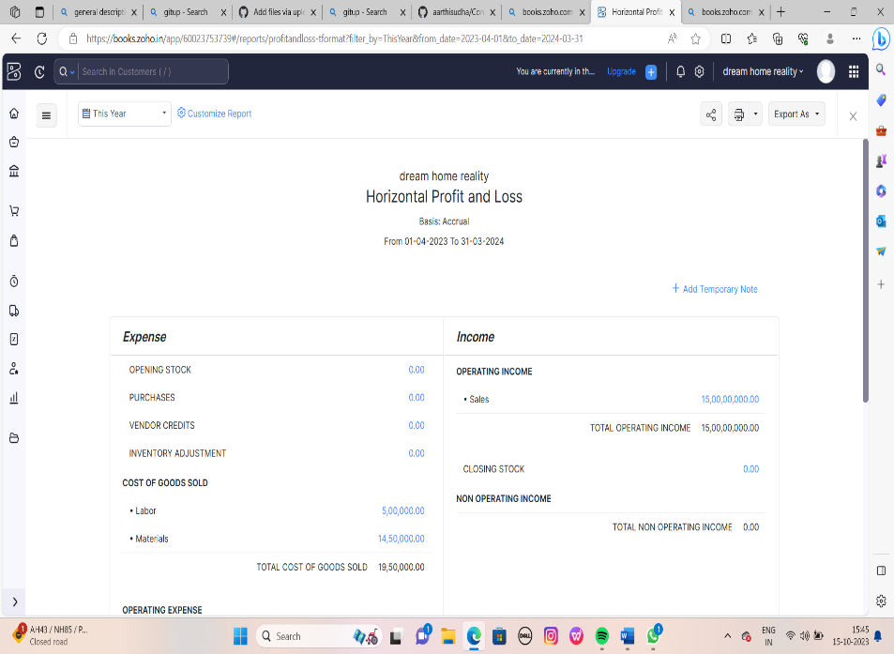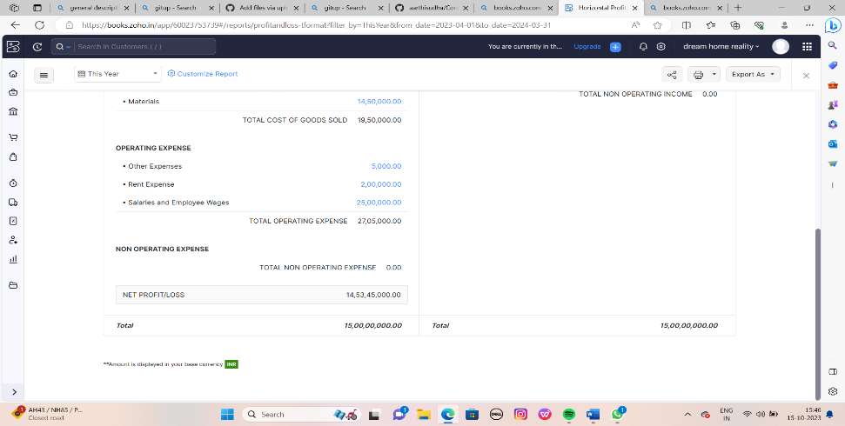

4 ADVANTAGES & DISADVANTGES

1. Cost-effectiveness
2. Feasibility
3. Improved focus
4. Identifying new opportunities
5. Providing valuable information
6. Narrowing business alternatives

DISADVANTAGES

* Poor productivity due to various issues such as design errors, planning oversights, and material shortages.
* Rising cost of materials and project overruns.
* Poor project performance and quality.
* Skilled labor shortages and low salaries.
* Serious long-term health issues from physical work and exposure to hazards.
* Delay in occupancy and risk of losing job or contract.
* Sustainability and efficiency challenges.
* Difficulty for women to enter the industry

APPLICATION

[Zoho Books is an online accounting software that helps businesses manage their finances, automate workflows, and collaborate across departments](https://www.zoho.com/books/) .

Smartintenz app help to learn the project and this app provide the workspaces about the project.

Gitup app help upload the project.

CONCLUSION

A project is very useful for students in zoho books we learn how to maintain a company and the we learn about the process of the company.

Future scope

In future we want more advantages and advanced methods to work with a application. Second level more development we want.